Rotations: A transformation where a figure is turned about a given point.

1. Triangle ABC is labeled on your graph below.
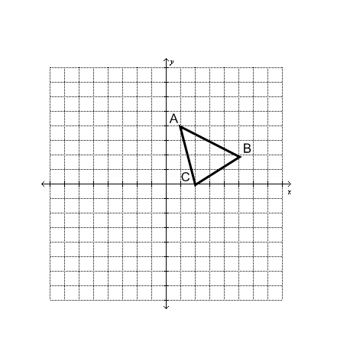
- Rotate Triangle ABC, 90º counterclockwise about the origin. Label the triangle A′ B′ C′.
- Rotate Triangle ABC, 180º counterclockwise about the origin. Label the triangle A″ B″ C″.
- Rotate Triangle ABC, 270º counterclockwise about the origin. Label the triangle A′′′ B′′′ C′′′.

.

Organize your results from in the table.

Starting Point | 90°  Rotation CC | 180°  Rotation CC | 270°  Rotation CC | 360°  Rotation CC
A (1, 4)
B (5, 2)
C (2, 0)

Complete each rule for finding the image of any point (x, y) under the given rotation.

a) 90° rotation about the origin: (x, y) → ( , )
b) 180° rotation about the origin: (x, y) → ( , )
c) 270° rotation about the origin: (x, y) → ( , )
d) 360° rotation about the origin: (x, y) → ( , )

