How Do Shapes Change
Dilations and Similar Figures
Have you ever wondered how different mirrors work? Most mirrors show you a reflection that looks just like you. But other mirrors, like the mirrors commonly found at carnivals and amusement parks, reflect back a face that is stretched or squished. You may look taller, shorter, wider, or narrower. These effects can be created on the computer if you put a picture into a photo program. If you do not follow the mathematical principles of proportionality when you enlarge or shrink a photo, you may find that the picture is stretched thin or spread out, and not at all like the original. Today you will look at enlarging and reducing shapes using dilations to explore why a shape changes in a certain way.
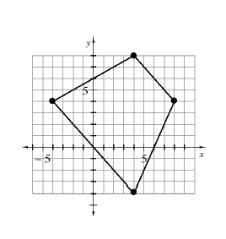
6-52 UNDOING DILATIONS
Charlie multiplied each coordinate of the vertices of a shape by 4 to create the dilated shape at the right.
- If Charlie multiplied to find his shape, what operations would undo the dilation? Why?
- On Lesson 6.2.2A Resource Page, undo the dilation on the graph above. Label the vertices of Charlie’s original shape. How does the shape compare to the dilated shape.
6-53 Alana was also working with dilations. She wondered “What would happen if I multiplied each coordinate of a shape by 1/3?” On the Lesson 6.2.2A Resource Page, graph and connect the points below to form her dilated shape. Be sure to connect them in the order given.
(-1, -1) (-1, 1) (1, 2) (2, -1)
- Alana graphed this shape by multiplying each of her original coordinates by 1/3. What do you think Alana’s shape looked like before the dilation? Make a prediction.

- On the same graph, undo the dilation to show Alana’s original shape. List the coordinates of the vertices of Alana’s original shape.

- What did you do to each coordinate to undo the dilation? How did the shape change?

- Why do you think the shape changed in this way?

6-54. With your partner, look carefully at Alana’s dilated and original shapes in problem 6-53 and describe how the two shapes are related. Use the questions below to help you.
- How are the sides of the small and large shape related?

- How many of the small sides does it take to measure the corresponding (matching) side of the large shape? Is this true for all of the sides?

- Compare the four angles of the smaller shape to those of the larger shape. What can you say for sure about one matching pair of these angles. What appears to be true about the other three pairs?
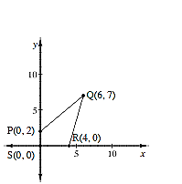
6-55 Changing Shape
When you multiply each coordinate of a shape by the same constant, you saw that sometimes the shape became smaller and sometimes it became larger. With rigid transformations, you move shapes on a graph without changing their size or shape by rotating, reflecting and translating. Dilations are non-rigid transformations since the size does change.
6-56 Use resource page 6.2.2B, graph each of the shapes described below.
- Dilate each coordinate of shape PQRS by multiplying each x-coordinate and each y-coordinate by 4. What are the coordinates of the dilated shape?

Graph the dilated shape in red.
- Go back to the original shape, and this time only multiply the x-coordinates by 3. Leave the y-coordinates the same. What are the coordinates?

Graph this shape in blue.

- What happened to the shape in part (b)? Why did this happen?

- What would happen if you only multiply the y-coordinate by 3 and did not multiply the x-coordinate? Explain why.

